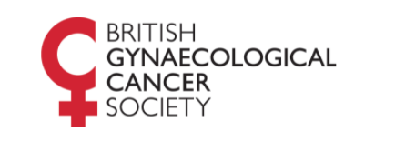
BGCS Clinical Oncology Forum

Thursday 18th November 2021, 4.30pm – 6.30pm

The first BGCS quarterly virtual meeting to discuss
Complex Gynaecology Oncology
Radiotherapy and Brachytherapy cases

Chairman and meeting organiser
Hoda Al-Booz
Consultant Clinical Oncologist
Bristol Cancer Institute University Hospital of Bristol

Committee members
Alexandra Taylor
Consultant Clinical Oncologist, Royal Marsden Hospital
Dennis Yiannakis
Consultant Clinical Oncologist, Lancashire Teaching Hospitals NHS Trust
Shaymaa Hosni
Consultant Clinical Oncologist, Nottingham University Hospital NHS Trust

To register please click this link and indicate if you would like
to share a complex case for discussion by emailing the BGCS Administrator

BGCS Administrator
administrator@bgcs.org.uk

